**Which kind of traversal of a binary search tree produces the values in sorted order?**

The type of transversal that would sort a binary tree in sorted order would the In-Order type.

Each node is examined as LNR:

Left of the node is examined first, then the node itself, then right of the node. Below is an example of a binary tree being examined with the In-Order type.

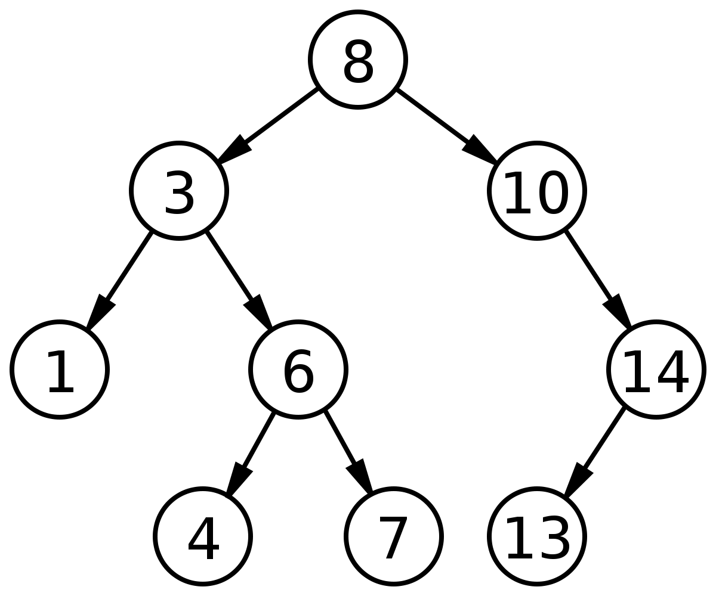

Starting at the top node of the tree, the left of node 8, then 3 get examined first making the left most node to be examined which is 1.

Result: 1

Backtracking to 3, that node is examined before going to the right of 3.

Result: 1, 3

To the right of 3 is 6, which examines its left child first which is 4.

Result: 1, 3, 4

Backtracking to node 6, it is examined, then the child to its right is examined which is 7.

Result: 1, 3, 4, 6, 7

All the nodes to the left of the top node (8), so that node is examined then starts examining nodes to its right.

Result: 1, 3, 4, 6, 7, 8

At node 10, there are no child nodes to the left so 10 is examined before examining the nodes to its right.

Result: 1, 3, 4, 6, 7, 8, 10

At node 14, the left child node is examined first which is 13.

Result: 1, 3, 4, 6, 7, 8, 10, 13

Returning to node 14, there are no more child nodes, so 14 is examined, completing the ordering of the nodes.

**Final Result: 1, 3, 4, 6, 7, 8, 10, 13, 14**